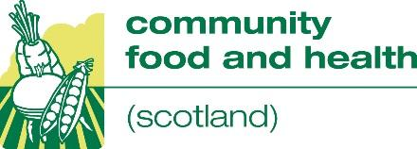
Hear Say

NHS Health Scotland’s Community Food and Health team organised their latest annual networking event on 24 October 2018.

Community activists, local practitioners, planners, policy makers and academics from across the country and sectors and disciplines came together in Dunfermline to hear a range of speakers, take part in table and workshop discussions and visit a busy marketplace.

Entitled Hear Say, the idea was that those who came together had a lot to say as well as hear and the theme for the day was building on learning.
The day was chaired by Lyndsay Clark, Senior Health Promotion Officer at Fife Health and Social Care Partnership.

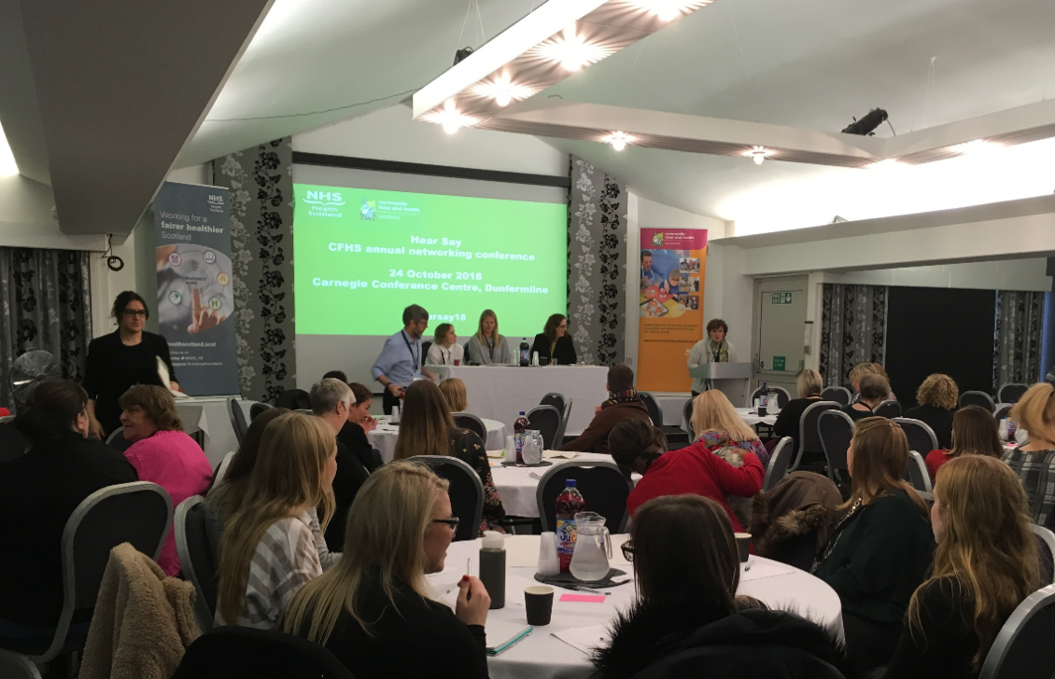
Following a warm welcome by the Chair, the event began with a panel discussion on ‘building on learning’ with Polly Jones, Project Manager at A Menu for Change; Lucy Aitchison, Manager at Broomhouse Health Strategy Group; and Lorraine Tulloch, Programme Lead, Obesity Action Scotland.
The first question concerned why and how the panel built on learning and a second looked at where now and what would help going forward?

Despite coming at this from different perspectives, the three speakers all emphasised how important acquiring and/or generating evidence was to making day to day decisions, influencing efficient practice and informing effective policy.

From listening to communities and robust monitoring of community activity to practice exchanges and action learning, alongside ensuring national and international evidence is placed before decision makers, the panel were agreed on what would assist them to continue to build on learning.

Understanding what learning is useful and recognising what is needed seemed to be a common issue. Similarly all three appreciated the benefit of having the flexibility to respond to opportunities and challenges in a dynamic practice and policy environment.

Finding the time and capacity to build on learning as much as they would like to, was seen as a constant challenge not only for the panellists but also when the questions were put out for discussion to conference participants at their tables.

‘This is all taking place under austerity, which hinders building on learning whilst making it more important than ever.’

https://menuforchange.org.uk/
http://healthstrategygroup.org.uk/
www.obesityactionscotland.org/

A couple of quotes from the table discussions which followed the panel discussion:

‘Build on learning by listening to the community, having work led by the community – it works when people lead’.

‘What would help you going forward: community buy in, partnership working, sustainable funding, engaging with communities, getting back to grass roots.’
________________________________________________________________________

Next came the morning workshop sessions:

1. Community empowerment and community food initiatives
Andrew Paterson from Scottish Community Development Centre (SCDC) presented information on the Community Empowerment Act and a discussion followed on how community food initiatives can benefit from this.

Andrew presented the different ways that parts of the Act such as participation requests and asset transfer requests can be used to influence services and use, lease or own land and buildings. Participants then discussed how they could make use of these opportunities in their areas (e.g. use of school classrooms for community cooking). Challenges of using the Act were also addressed, including issues around organisations that are at arm’s length to councils.
You can find Andrew’s presentation here.

2. Sustainable food cities and low-income communities
This workshop was kicked off by Iain Stewart, Chief Executive of Edinburgh Community Food and Ben Lejac, Edinburgh Sustainable Food Cities Co-ordinator.

A brief history of Edinburgh Community Food (ECF) and Edible Edinburgh was presented before focussing on how the former’s community development and city-wide approach, as well as its longevity, made it a key element of an effective multi-sector partnership and appropriate base for the sustainable food city co-ordinator.

After looking at ECF’s strategic aims and Edinburgh’s ‘sustainable food city plan’ the benefits of being part of a UK-wide Sustainable Food Cities Network was raised and particularly using the Sustainable Food Cities Award to secure further change. ‘At least bronze’ appeared to be the challenge that was bringing political, commercial and community interests together.

Future plans were noted, including a food summit next spring, a school-based initiative, and influencing cities growing strategy. It was also noted there were plans to work more closely with Scotland’s other sustainable food cities as well as UK-wide initiatives such as Food Power and Veg Cities.
Workshop participants came up with no shortage of current and future challenges for the city, from waste to austerity, and from allotments to supermarkets, but appreciated that the more joined up the city was the better prepared they would be to face these challenges.
You can find their presentation here.

www.edinburghcommunityfood.org.uk/
www.edible-edinburgh.org/
http://sustainablefoodcities.org/
www.sustainweb.org/foodpower/
http://sustainablefoodcities.org/awards
www.vegcities.org/

3. Community food initiatives and Type 2 diabetes
Gordon Thomson and Claire Mooney from Lanarkshire Community Food and Health Partnership used their recent experience to kick off a discussion about addressing type 2 diabetes.

A discussion followed on some of the challenges linking up with clinical pathways to support work as well as the importance of using leisure and community groups to support this work.

You can find their presentation here.

4. Food insecurity and the ‘Dignity in Practice’ programme
Chelsea Marshall from Nourish gave a presentation and discussion around their experience of delivering their ‘Dignity in Practice’ programme, working with 14 projects to gather evidence to support changing practice and putting into policy.

The workshop looked at what ‘dignity’ means, the definition of food insecurity – and the importance of the definition including being ‘socially acceptable’.

The ‘Dignity’ report (2016) supports the ethos of transition from emergency food provision to a ‘rights based approach to food. It highlights that food banks in Canada have become a fact of life. This is not what is wanted in Scotland

Key points from the discussion
- For most people it’s not just about nutrition, it’s the social experience as well
- Having the power to choose – autonomy in your own decisions
- Small details matter of how food is presented – words, access, environment

www.nourishscotland.org/projects/dignity/
www.nourishscotland.org/wp-content/uploads/2018/03/Dignity-in-Practice-Full-Report-March-2018.pdf

You can find Chelsea’s presentation here.

5. Making a difference with cooking skills courses
This workshop was led by Fiona Matthew from NHS Grampian. The workshop was split into 4 groups and each group worked on thinking about why they evaluated; who they were evaluating; what outcomes they hopes to achieve; and what indicators and tools they would use to find out if they were successful.

6. An open discussion on the future of community food activity in
Scotland

Led by Kim Newstead from CFHS, this workshop focussed on evidence and evaluation and using this better to influence (or contribute to) local and national priorities. The workshop was split into 3 groups and asked to discuss:

- What are you achieving?
What are the main outcomes/achievements of your collective food and health work?

- How do you know?
Choose one outcome/ achievement to focus on between you.
Discuss what evidence you have gathered for this outcome.

- So what?
How have you (or could you) share this evidence with others beyond your organisation?
Who with? What happened? What was successful and what wasn’t? Why not?
Does anyone have any ideas about how evidence on this outcome could better
influence others?

nformation from flipcharts:

Group 1: focused on outcome of ‘increasing partnership work’. Gathers evidence from individuals, meetings with partners and using wide range of reporting formats.

How the evidence can be better disseminated/ used to influence decision making = marketing, videos, via action groups, community empowerment, presentations.

Group 2: outcome focused on ‘reducing isolation’. Evidence from individual case studies, qualitative data.

Issues/ideas about evidence and influence: need time to consider and present information about impact (i.e.: not just funded time for delivery), better and more consistent links with academia, more time needed to plan longer term evaluation (e.g.: 10 years or more).

Group 3: Community initiatives can have powerful reports and lots of data. This can be used well for local publicity. Evaluation may focus on reporting to funders, which may only need minimal information.

The second half of the workshop focused on feedback and whole group discussion.

Key points from the whole group included:

- Working with a university has helped with ensuring more robust/credible evidence, however, this kind of opportunity is sporadic/ dependent on developing a relationship with university departments. Also need to be able to act quickly on evidence – academia can be too slow.

- Good evidence is not always enough to secure funding, local decisions also influenced by the unit cost. Are policy makers/funders interested in evidence?

The group discussed useful methods for disseminating and marketing evidence and evaluation to the community, including short videos.

________________________________________________________________________

After a break for lunch and networking and the chance to visit the marketplace, it was time for the afternoon workshop sessions:

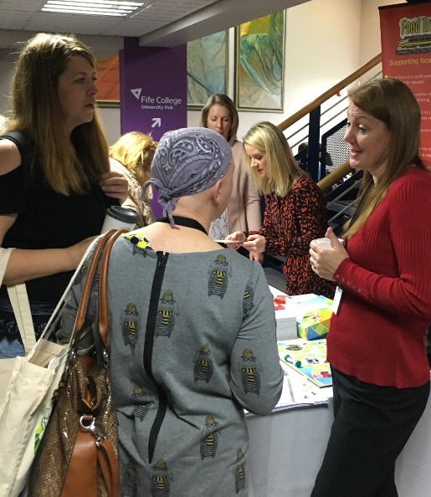
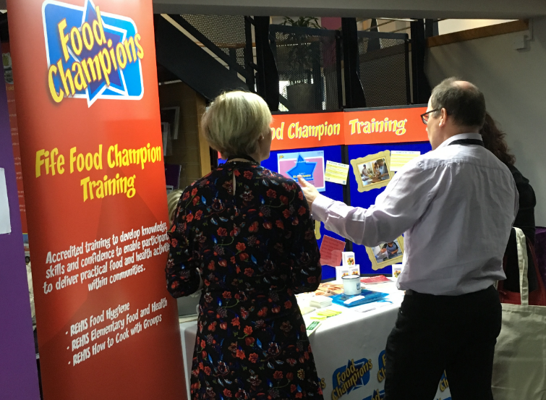

1.Tips and ideas for successful community-led research
Florence Dioka, Lesley Greenway and two volunteers from Central and West Integration Network (CWIN) led a discussion on how they have supported volunteers to lead and carry out research on food security/diet and obesity within a range of minority ethnic groups.

The workshop looked at
- What community led research means.
- How to do it.
- What community members get out of it. Building on people’s skills and strengths, understanding the community, languages, culture, sharing experiences - the group members engage with other groups and local people. Existing volunteers mentor new volunteers, they asked people, volunteers and policy makers

Workshop participants had the opportunity to use a few of the basic techniques; examples of activities to use to create opportunities to get to know people and for discussion. CWIN used the process for finding out about people’s experience of food insecurity, and are currently using this process, looking at obesity and diet.

Two community researchers gave an account of what it meant for them, the challenges in language, culture and perspectives of different people and how they can be overcome.
Volunteers now understand about obesity and food security, and made new connections, both socially and for the organisation.

This workshop generated a lot of discussion. Participants were actively talking about how they could use this style of research in their work.
You can find their workshop handout here.
www.cwin.org.uk/
www.cwin.org.uk/assets/Uploads/CWIN-research-report-2016.pdf
www.communityfoodandhealth.org.uk/advice-resources/making-a-difference/research/communityled-research/
2.Using a community development approach to running community
cooking skills courses
Led by Christine Dallas from the Community Health Team Dundee and Caroline Baimer from Dundee City Council

Christine and Caroline outlined their work in the local community and with other agencies to encourage people to attend community activities including cooking sessions and how they encourage people to move onto other activities including volunteering. Two volunteers, Ethel and Angela, discussed their journeys from cooking classes to volunteering for other work.

The workshop was split into two groups. Each group was tasked to define community development in one sentence, after using various agency definitions to refer to.

The groups were then asked to discuss some of the main tasks involved in setting up cooking sessions for either men, or parents with young children. Practical questions covered recruitment, involving participants in shaping the course, considering how to signpost people onto other activities or services, and evaluation. Word of mouth and speaking to people at various venues (pubs, shops etc), working with other agencies (social work etc) were considered more appropriate than using posters and leaflets to try and recruit. Involving people in the course included finding out people’s likes and dislikes, evaluation included thinking about using a range of methods and sources of information.

3.Older People and Malnutrition – where next?
Michelle Carruthers, Emma Black and Laura Cairns presented information on the Food Train, Meal Makers and Eat Well Age Well.

Michelle highlighted the developments of the food train since its introduction in 1995 and the key developments both in terms of policies and services over that time. The presentation highlighted the extent of the challenges faced in terms of malnutrition. Emma explained how Meal Makers works and highlighted the progress made since September 2014 when the service begun. Finally Laura presented Eat Well Age Well, a 3.5 year project funded by Big Lottery, to support the prevention, detection and treatment of malnutrition and dehydration among older adults (over 65) living at home in Scotland.

Participants in the workshop discussed the challenges of malnutrition and what they could do to support getting the message out about the work of the Food Train, Meal Makers and Eat Well Age Well.

www.foodtrain.co.uk
www.mealmakers.org.uk
www.eatwellagewell.org.uk

You can find their presentation here.

4. Edible and tasty spaces: growing fruit and veg in public spaces
Karen Dorrat from Eats Rosyth kicked off a discussion on what they have learned about setting up, maintaining and encouraging local people to make the most of edible and tasty spaces. Karen highlighted how much they are doing including community cooking events and highlighting food waste. A discussion followed with people talking about their own experiences of community growing and the challenges of recruiting and sustaining volunteers.
You can find her presentation here.
5.An open discussion on the future of community food activity in Scotland (led by Bill Gray from CFHS)

What would allow the scope and scale of your initiative to better influence the design and delivery of national and local priorities around food and health in the years to come? Working at table level and then as a whole room, the experienced group who addressed the above question raised common hopes, concerns and solutions.

- Understanding breeds trust. Opportunities to build relationships between practitioners, planners and policy makers, locally and nationally, could address short termism and reinventing the wheel.
‘We shouldn’t have to be always having to prove ourselves.’

- Being valued needs to be illustrated in practice. Places on partnerships and steering groups are welcome but the weight given to local knowledge and the quality of community involvement is crucial.
‘We know our communities and that is appreciated by some more than others.’

- Outcomes are enhanced when the strengths of community initiatives are invested in. Local initiatives are generally more acceptable and approachable, particularly to marginalised groups, through their person-centred, non-prescriptive and preventative approach.
‘‘We don’t just know what will work, we also know what won’t.’

- Sustaining activity requires being part of the system. Whilst valuing the autonomy of initiatives, strategies and pathways which consistently and formally recognise the role of communities, should underpin longer term planning.
‘It sometimes feels like we are only of interest when it suits.’

This very knowledgeable workshop reflected decades of experience in community food activity from around the country, operating varied systems and structures. However, everyone looked forward to practical measures, strategically underpinned, that would continue to value diversity and locally informed, community-led approaches alongside a national commitment to enhance and sustain the work consistently across the country.
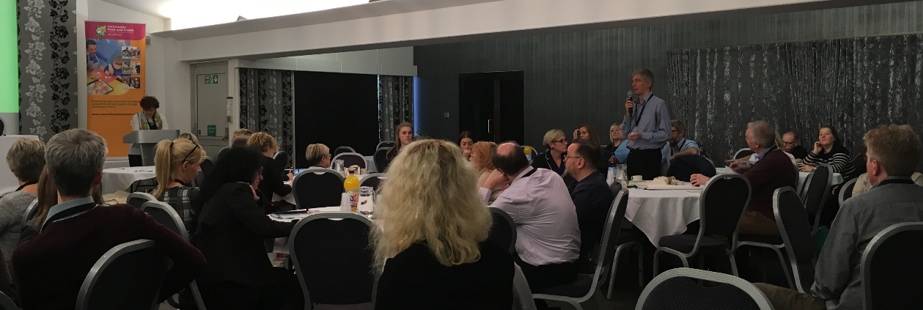
______________________________________________________________________
The day ended with some timely Government announcements and reflections from the delegates and the chair. Thanks to all who contributed to the day.

