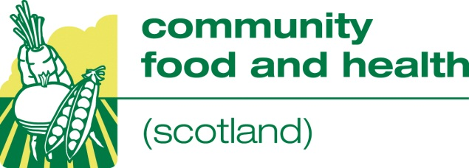

Evaluating Outcomes

We are offering organisations the opportunity to book a place on one of two “Evaluating Outcomes” sessions provided for us by Evaluation Support Scotland. Each day will give participants a basic introduction to evaluation and they will be held on:

• Thursday 20 November 2014, (9.45 – 4.00) Edinburgh
• Thursday 12 February 2015 (9.45 – 4.00) Glasgow

To book a place, tell us who wants to take part, where they want to attend and if appropriate provide the additional information requested. The form should then be returned to Jacqui McDowell at NHS Health Scotland, Gyle Square, 1 Gyle Crescent, Edinburgh, EH12 9BE

Organisation …………………………………………………………………………………………

Name …………………………………………………………………………………………………..

Address ………………………………………………………………………………………………..

E-mail …………………………………………………………………………………………………..

The Evaluation Outcomes session I wish to attend is Glasgow Edinburgh
(Please delete as appropriate)

Tell us about any special needs you have (diet, access or communication).

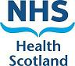
Please return the form to Jacqui McDowell at Jacqueline.McDowell@nhs.net or the address above, places will be reserved on a first come first served basis.

