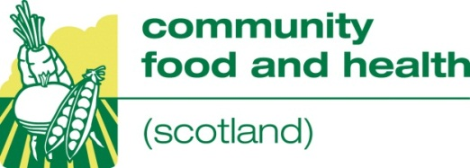
CFHS Study Tour 1-3 October 2013
Approaches to improving food access/ addressing food poverty with older people

Programme
Tuesday 1 October
am Travel to London and arrive hotel
2.30 Casserole Club
Dominic Campbell, Director , Matt Skinner, Design and Change Lead. Futuregov
4.15 Community Catalysts
Lisa Taylor, Commissioning Officer, Micro-enterprise - London Borough of Newham
7pm Dinner
Wednesday 2 October

9.30 Greenwich Co-operative Development Agency
Claire Pritchard

12.30 Lunch

London's Kitchen at City Hall
2.00 London Assembly
City Hall, The Queen’s Walk, SE1 2AA
Rosie Boycott .Chair London Food Board
Mark Ainsbury, Jonathan Pauling. London Food Team

3.00 Fiona Twycross. London Assembly Member
Simon Shaw, Assistant Scrutiny Manager

3.45 London Borough of Southwark
160 Tooley Street, SE1 2QH
Andy Loxton, Lead Commissioning Manager, Universal Services
5.15 London Circle
2 Swan Court, Tanner Street, SE1 3LE
Cath Dillon. Enterprise Director. Participle

7.30 Dinner
Thursday 3 October

9.00-10.30 Malnutrition Task Force
Age UK, Tavis House, 1-6 Tavistock Square WC1H 9NA
Margit Physant - Project Manager

11.00 New Horizons Centre
New Guinness Trust Estate SW3 2PF
Roshan Raghavan – Day. Project Manager

12.30 Lunch
Orangery Café, New Horizons Centre
Mel Lewis - Café Manager

pm Return travel to Scotland

